

**Pep Rally a Smash Hit**

“It is wiser to find out than to suppose.” – *Mark Twain*

***Issue #3***

**BullPen Staff**

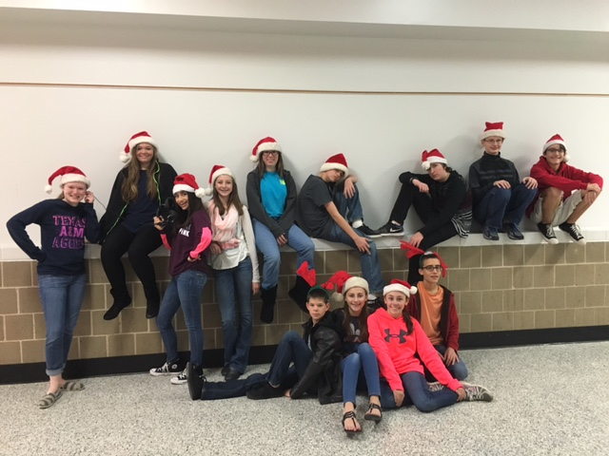

**Inspirational Quote:**

Travis

**Extra News:**

Daniel

Connor

**Student Spotlight:**

Amanda

Chandler

**Logic Puzzle:**

Dillon

**Headline:**

Lilly

Morgan

**Head Editor:**

Carson

**Editors:**

Charlie

Justin

**Comics:**

Teralynn

Will

Karlie

**D.I.Y:**

Maddie

Sarah

**Trends:**

Ian

**Sports:**

Joseph

Dakota

**Teacher Highlight:**

Taylor

Robbin

**Inspirational Quote:**

Travis

**Extra News:**

Daniel

Connor

**Student Spotlight:**

Amanda

Chandler

**Logic Puzzle:**

Dillon

**Happy Holidays from the BullPen Staff**

Happy Hanuka, seasons greetings, happy holidays,

filiz navidad, Mele Kalikimaka, however you might

say it Merry Christmas! We are wishing you th eWe

hope you all have a safe and wonderful Christmas.

Stay warm, drink lots of hot cocoa, and have a great

break. Best wishes from 8th grade G.T.

**\*\*\* Extra News \*\*\***

Everyone in Mrs. Masse’s art class will be doing the 3-D star project for Christmas. Advanced students will be creating a complex 20 circle spheres. Once completed, all the stars and spheres will be displayed in the glass container next to the office for everyone to see.

Don’t forget to come for the band’s Christmas performance on Dec. 17(Thursday) at the high school auditorium.

EDITORS

Carson Stark, Justin Hulsey, Charles DuBas

**Mind Bender**

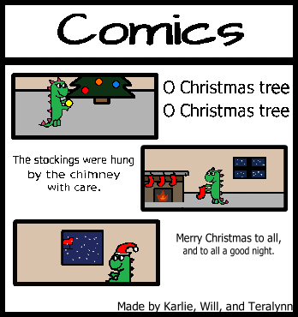

Santa is flying through a blizzard. Rudolph can't fly because he’s sick. What's lighting the way?

Hint: Santa bought a DELUXE sleigh

Answer: New headlights.



**DIY: Homemade Peanut Butter**

Instructions

Prep time: About 20 min.Cook10 min.

Directions:

1. Mix flour, ginger, cinnamon, baking soda, nutmeg and salt in large bowl. Set aside. Beat butter and brown sugar in large bowl with electric mixer on medium speed until light and fluffy. Add molasses, egg and vanilla; mix well. Gradually beat in flour mixture on low speed until well mixed. Press dough into a thick flat disk. Wrap in plastic wrap. Refrigerate 4 hours or overnight.
2. Preheat oven to 350 degrees F. Roll out dough to ¼ inch thickness on lightly floured work surface. Cut into gingerbread men shapes with 5-inch cookie cutter. Place 1 inch apart on ungreased baking sheets.
3. Bake 8to 10 until edges of cookies are set and just begin to brown. Cool on baking sheets 1 to 2 minutes. Remove to wire racks; cool completely. Decorate cooled cookies as desired. Store cookies in airtight containers up to 5 days. By: Sarah and Maddie

*From Allspice.com*

Ingredients

1. 3 cups of flour

2. 2 teaspoons McCormick Ginger, Ground

3. 1 teaspoon baking soda

4. ¼ teaspoon McCormick Nutmeg, Ground

5. ¼ teaspoon salt

6.¾ cup softened butter

7. ¾ cup firmly packed brown sugar

8. ½ cup of molasses

9. 1 egg

10. 1 teaspoon McCormick Pure Vanilla Extract

**Teacher Spotlight**

**Susan Marek**

**Teralynn Howard**

**Will Beausoleil**

**Karlie Bye**

**Student Spotlight**









Mrs. Susan Marek is the theater teacher, GT teacher and has D.I. team at Bellville Junior High. Her favorite Christmas memory is watching her 4 children open presents. She believes Christmas is a time for giving, not receiving. Mrs. Marek’s favorite Christmas food is chocolate santas. Sorry Santa!

Will’s favorite Christmas food is pie and he like to eat it with hot cocoa. The best gift he has ever got was an ornament and this year he wants some Disney onesies. His favorite Christmas tradition is decorating the house and tree.

Teralynn's favorite thing to do during Christmas is to decorate the Christmas tree and likes to drink hot chocolate. The best Christmas gift she ever received was her computer, and her #1 item on her list this year is books.

Karlie’s most wanted item on her Christmas list is a laptop and the best gift she ever received is a heart shaped necklace from Santa. Her favorite Christmas food and drink is Cookies and hot chocolate, and her favorite Christmas tradition is picking out a Christmas tree.